**Collections Frawework**

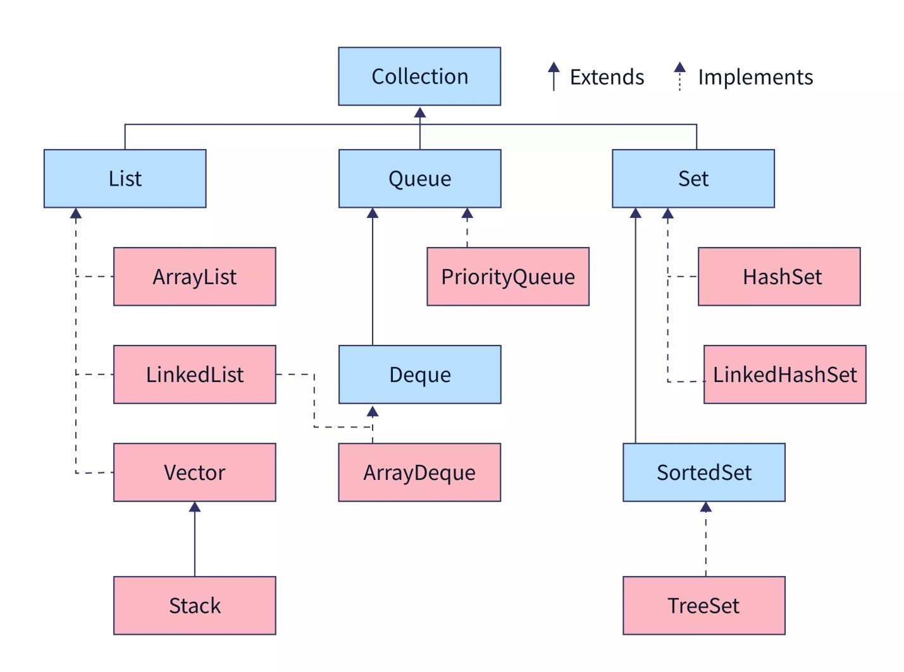

The **Java Collections Framework** is a unified architecture for storing and manipulating groups of objects. It includes interfaces and their implementations for various data structures like lists, sets, maps, queues, etc. This framework simplifies development by providing built-in methods to handle common operations like searching, sorting, inserting, and deleting data.

**Components of the Collections Framework:**

1. **Interfaces**: Define the abstract data types that collections can implement. The primary interfaces are:
   * **Collection**: The root interface of the framework.
     + **List**: An ordered collection that allows duplicates (e.g., ArrayList, LinkedList).
     + **Set**: A collection that does not allow duplicates (e.g., HashSet, TreeSet).
     + **Queue**: A collection used to hold multiple elements before processing (e.g., PriorityQueue, LinkedList).
   * **Map**: A collection that maps keys to values (e.g., HashMap, TreeMap).
2. **Implementations (Classes)**: These are concrete classes that implement the interfaces. Common implementations include:
   * **ArrayList**, **LinkedList** for List.
   * **HashSet**, **TreeSet** for Set.
   * **HashMap**, **TreeMap** for Map.
3. **Algorithms**: The framework provides algorithms for manipulating collections, such as sorting, searching, and shuffling.

**Example: Java Collections Framework in Action**

**Scenario:**

We will create a simple system to store a collection of employee records, where:

* Employees are stored in an ArrayList (a type of List).
* Employee IDs are stored in a HashSet (a type of Set) to ensure no duplicate IDs.
* A HashMap will map employee IDs to employee names, making it easy to look up an employee by their ID.

**import java.util.*;**

**class Employee {**

**private int id;**

**private String name;**

**public Employee(int id, String name) {**

**this.id = id;**

**this.name = name;**

**}**

**public int getId() {**

**return id;**

**}**

**public String getName() {**

**return name;**

**}**

**@Override**

**public String toString() {**

**return "Employee{id=" + id + ", name='" + name + "'}";**

**}**

**}**

**public class CollectionFrameworkExample {**

**public static void main(String[] args) {**

**// List to store multiple employee records**

**List<Employee> employeeList = new ArrayList<>();**

**// Set to store unique employee IDs**

**Set<Integer> employeeIdSet = new HashSet<>();**

**// Map to store employee ID as key and employee name as value**

**Map<Integer, String> employeeMap = new HashMap<>();**

**// Adding employees to list and map**

**Employee emp1 = new Employee(101, "Alice");**

**Employee emp2 = new Employee(102, "Bob");**

**Employee emp3 = new Employee(103, "Charlie");**

**// Adding employees to ArrayList**

**employeeList.add(emp1);**

**employeeList.add(emp2);**

**employeeList.add(emp3);**

**// Adding employee IDs to HashSet (ensures uniqueness)**

**employeeIdSet.add(emp1.getId());**

**employeeIdSet.add(emp2.getId());**

**employeeIdSet.add(emp3.getId());**

**// Adding employee details to HashMap for quick lookup**

**employeeMap.put(emp1.getId(), emp1.getName());**

**employeeMap.put(emp2.getId(), emp2.getName());**

**employeeMap.put(emp3.getId(), emp3.getName());**

**// Displaying employee details using List**

**System.out.println("List of Employees:");**

**for (Employee employee : employeeList) {**

**System.out.println(employee);**

**}**

**// Checking uniqueness of employee IDs using Set**

**System.out.println("\nSet of Employee IDs (no duplicates):");**

**for (Integer id : employeeIdSet) {**

**System.out.println("Employee ID: " + id);**

**}**

**// Fetching employee name by ID using Map**

**System.out.println("\nEmployee Lookup by ID:");**

**int searchId = 102;**

**if (employeeMap.containsKey(searchId)) {**

**System.out.println("Employee with ID " + searchId + ": " + employeeMap.get(searchId));**

**} else {**

**System.out.println("Employee not found.");**

**}**

**}**

**}**

**Output:**

**List of Employees:**

**Employee{id=101, name='Alice'}**

**Employee{id=102, name='Bob'}**

**Employee{id=103, name='Charlie'}**

**Set of Employee IDs (no duplicates):**

**Employee ID: 101**

**Employee ID: 102**

**Employee ID: 103**

**Employee Lookup by ID:**

**Employee with ID 102: Bob**

**Explanation of Code:**

1. **List** (ArrayList<Employee> employeeList):
   * Used to store multiple employee records in the order they are added.
   * The ArrayList allows duplicate elements, but in this example, we ensure each employee is unique by design.
2. **Set** (HashSet<Integer> employeeIdSet):
   * Used to store unique employee IDs.
   * HashSet is used to ensure no duplicate IDs are added, which is helpful when you want to maintain uniqueness.
3. **Map** (HashMap<Integer, String> employeeMap):
   * A HashMap is used to map employee IDs (keys) to employee names (values). This provides fast access to employee information by their ID.

**Overview of Key Java Collections:**

1. **List Interface**:
   * Allows duplicates.
   * Ordered collection, i.e., elements are stored in the order they are added.
   * Implementations: ArrayList, LinkedList, Vector.
   * Example: ArrayList<Employee> employeeList.
2. **Set Interface**:
   * Does not allow duplicates.
   * Unordered, but some implementations maintain specific order (e.g., TreeSet).
   * Implementations: HashSet, LinkedHashSet, TreeSet.
   * Example: HashSet<Integer> employeeIdSet.
3. **Map Interface**:
   * Stores key-value pairs.
   * Keys must be unique, but values can be duplicated.
   * Implementations: HashMap, TreeMap, LinkedHashMap.
   * Example: HashMap<Integer, String> employeeMap.

**Advantages of the Collections Framework:**

* **Reduces Development Time**: Provides ready-made data structures like List, Set, and Map with methods for adding, removing, searching, and sorting elements.
* **Reusability**: You can reuse existing collection implementations without needing to write your own data structures.
* **Performance**: Offers optimized algorithms for working with data structures, which results in better performance in most use cases.
* **Flexibility**: Allows switching between different collection implementations (e.g., changing an ArrayList to a LinkedList) without changing much of the code.